**A2:**

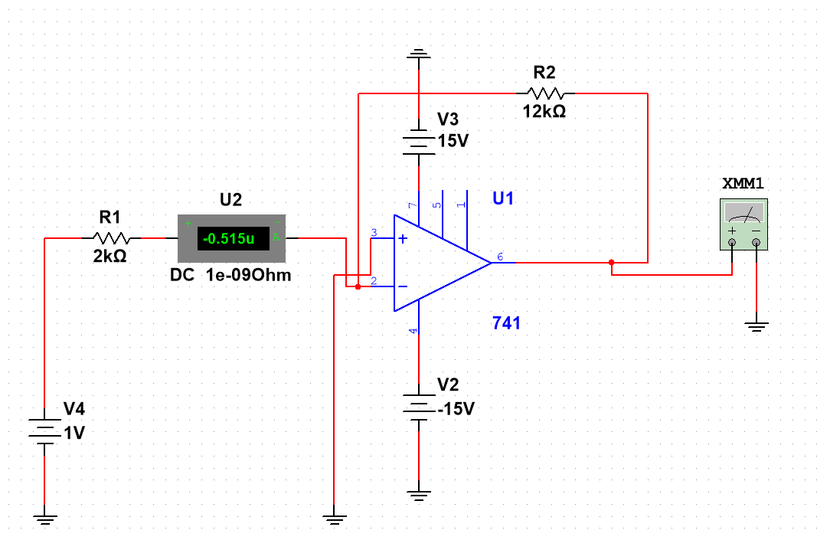

**A3**.

Vs * (Rf/R1) = V0

1 * (12/2) = 6 V

**A4:** 1 V / (0.449 * 10^-3) = 2227.171 Ohms

**A5.**

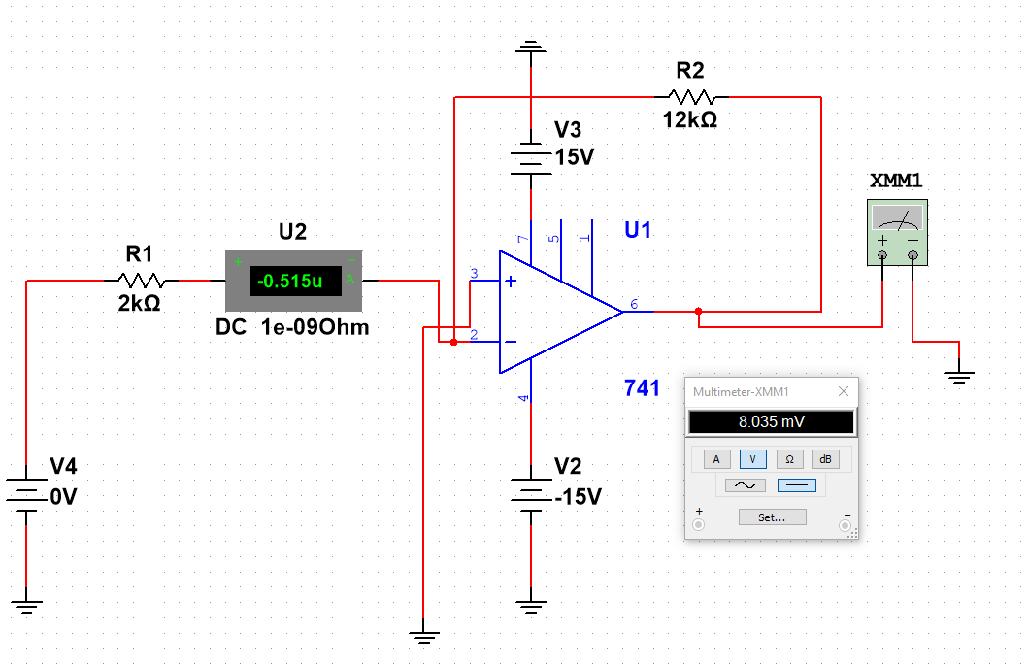

8.035 mV

**A6.**

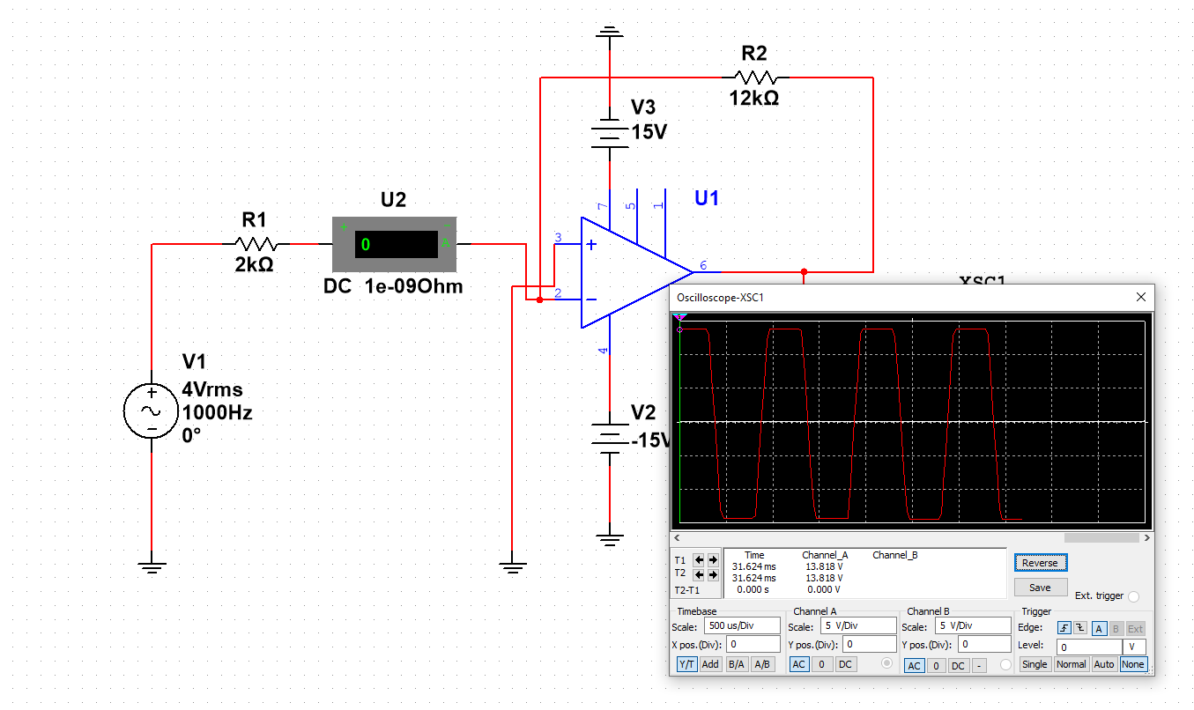

**B1:**

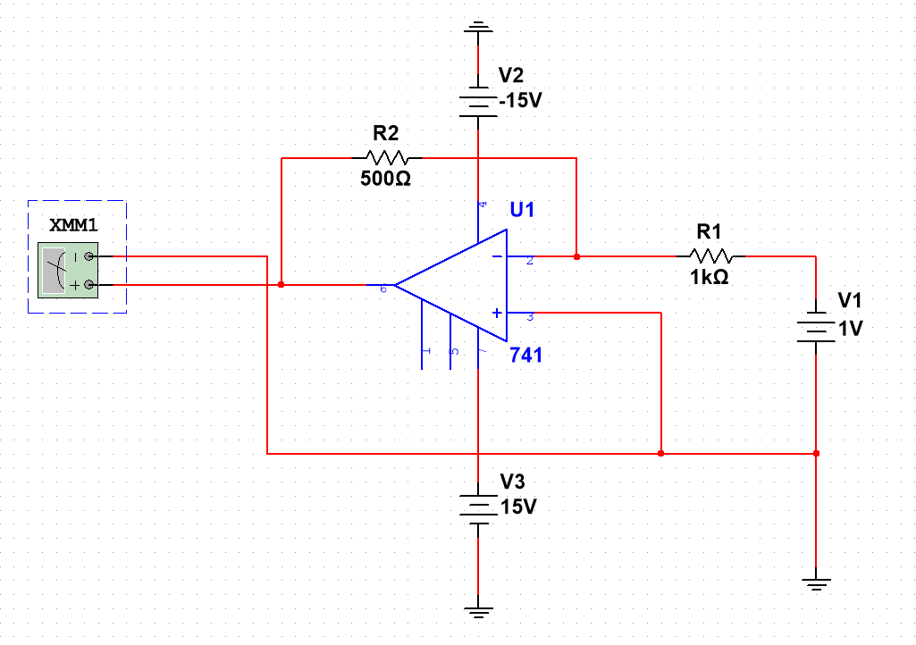

**B3:**

Expected : Recorded

200 : 201.247

500: 501.574

1k: 1.002

2k: 2.003

5k: 5.006

**B4:**

Resistor : Percentage error

200 : 0.6235%

500 : 0.3148%

1k : 0.2%

2k : 0.15%

5k : 0.12%